Longitudinal Study Data Processing:

Everyone’s Data:

1. Open the “everyone data” file.
2. Cut and paste each ANSWER column into a different word file.
3. Spell check each word file.
4. Save each word file as the TEXT column name and time data number.

Example:

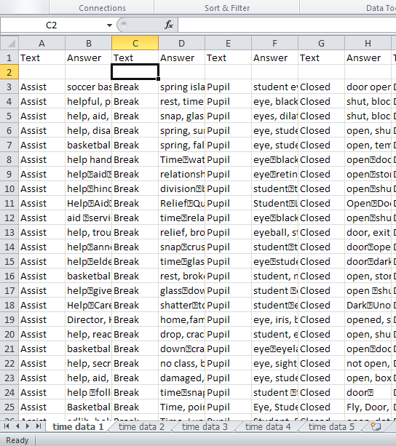

The data file – notice how all 5 time measurements are in this file. There are separate sheets for each one.

I’m going to copy the ANSWER column into a word file.

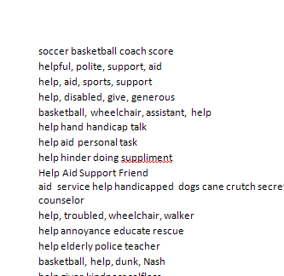

Now go through and spell check / fix all the spacing errors.

Save the file as the TEXT column name before that answer column – here it would be ASSIST (since I copied the first answer column). I am working on time 1, so the name would be “assist1”.

You will end up with 5 files for each word X 20 words = 100 files.

Hints:

Sometimes people run things together with commas – you could do an replace of all the commas with a space. Go to the home menu – on the right hand side is replace.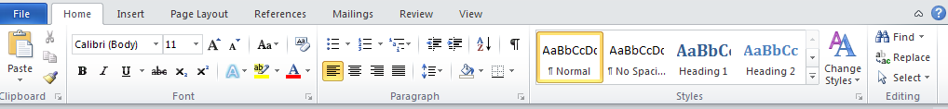

In the find part put a comma , and in the replace part be sure to hit the space bar.

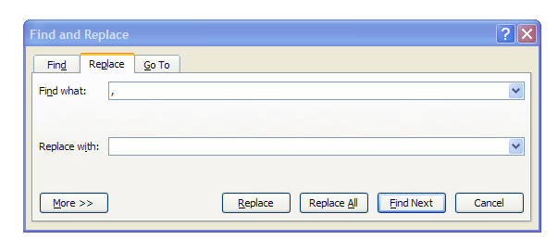

Hit replace all to get rid of the commas and have the spaces. You can have multiple spaces, that’s not a big deal.

Individual File Processing:

1. Open slope intercept data.
2. Open data by subject (or data by subject 2).
3. Cut and paste the person’s “real numbers” into the intercept data file – be sure to label who you are pasting.
4. Go to inqsit online – you can click this link:
   1. <https://learning.missouristate.edu/inqsitor/index.cgi>
   2. Select Buchanan from the drop down box.
   3. Click on instructors and surveyors.
   4. In the top left corner type erin as the password all lowercase.
5. Find the file of the person you are working on by using the drop down box in the top left corner – labeled module.
6. When you click on their name – don’t be surprise if it doesn’t do anything. Click module management on the left hand side.
7. Now click export data on the right hand side.
8. Unclick all the boxes except question text and answer.
9. Click one question per line under number 3.
10. Hit export now – this button will download an excel file with their answers.
11. Cut and paste their answers next to the real answers.
    1. You can use the text to columns information and data sort described below to make them line up alphabetically.
12. Create a new sheet for the next person.
    1. You can label each sheet separately or just label them somewhere on the sheet.

Example:

I’m going to do a_economon’s files (there are LOTS of tabs – you’ll want to scroll through them to find the right person).

Here’s the real answers data (data by subject 2):

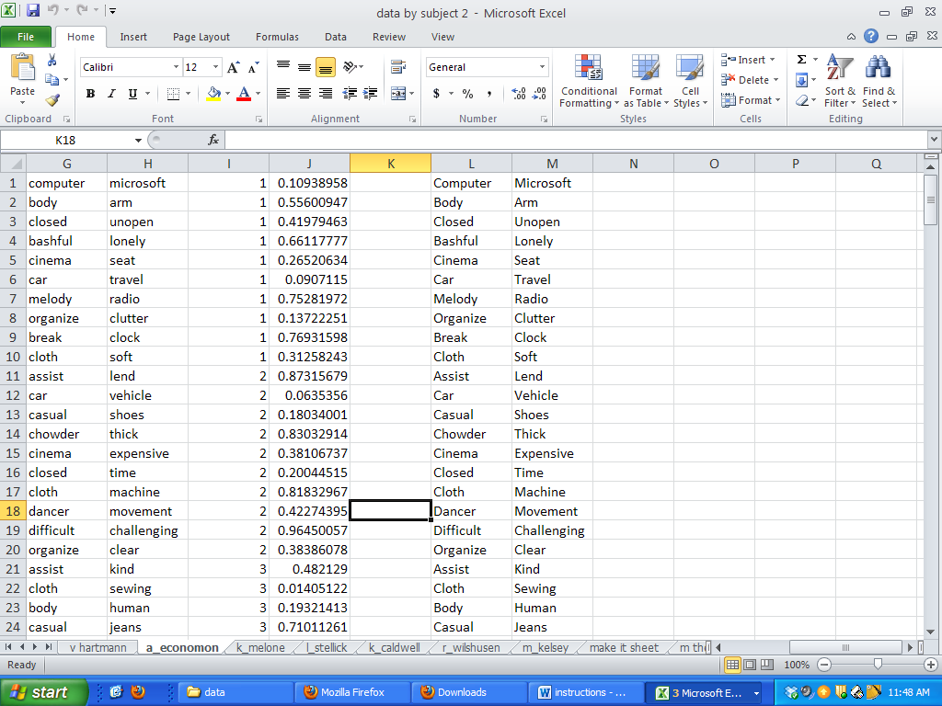

There will usually be several columns – one very long set of columns with a bunch of numbers, one set with only 50 words/numbers, and then the last set is usually the capitalized set. Use the middle, where there are 50 lines.

I want only the words and first number (remember that the decimal numbers were to help me put them in a random order).

I’m going to cut and paste those into a new sheet in the slope intercept file:

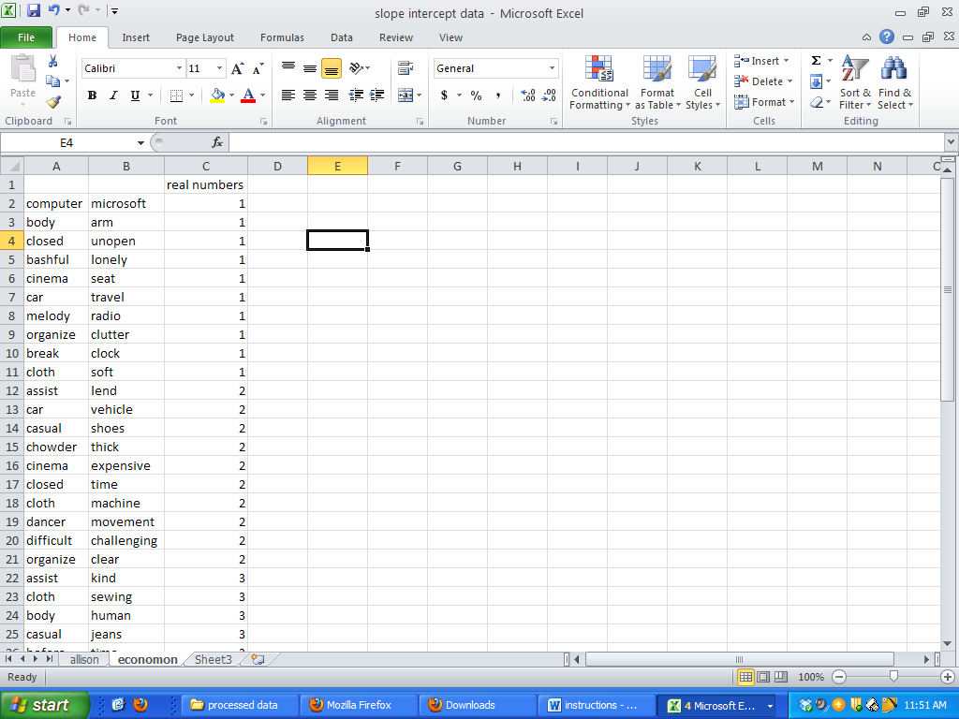

Now I need to get the written numbers from Inqsit. Go to the link provided.



Select Buchanan and instructors and surveyors.

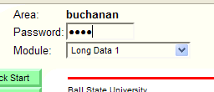

Type erin into the password box.

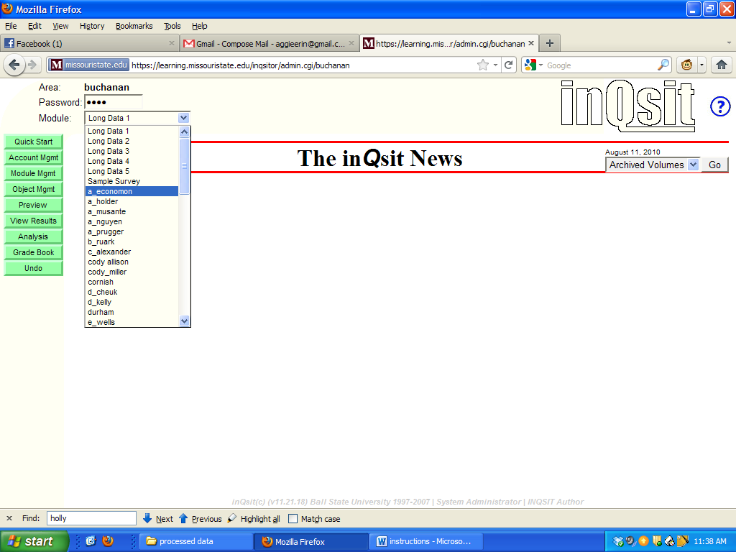

Select which person you want to view from the module drop down box.

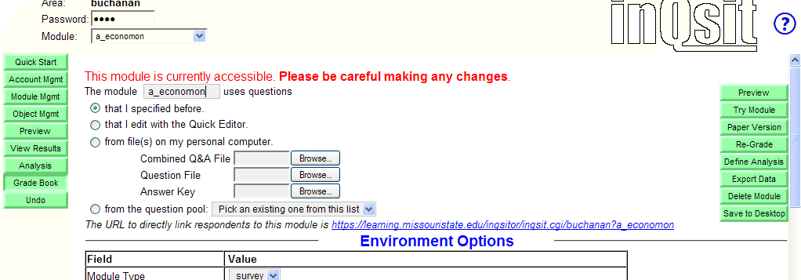

Hit module management.

Hit export data.

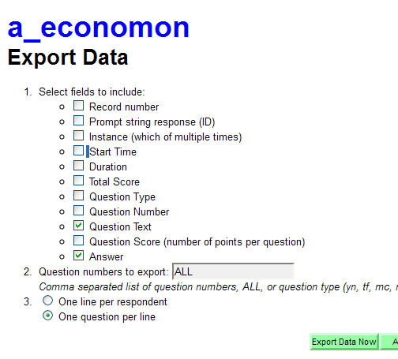

Select only question text and answer, then one question per line for number 3. Hit export data now.

In the excel file, I’m going to select only the words with numbers next to them (sometimes there’s a set of blank responses).

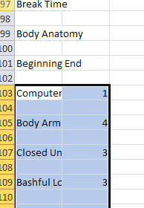

Paste those into the slope intercept file.

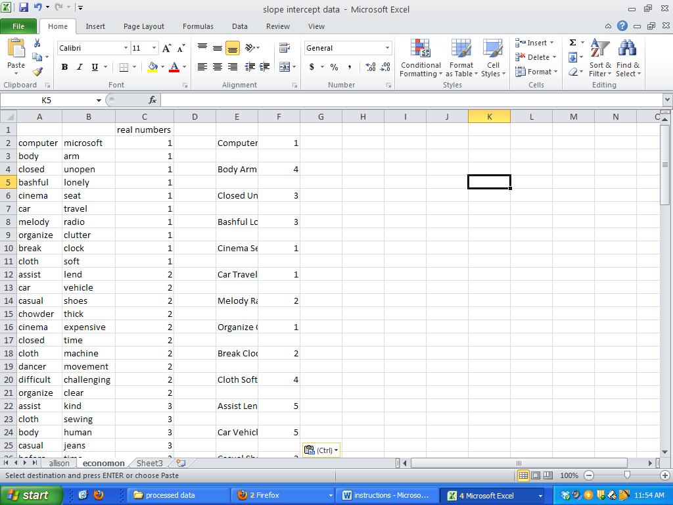

Text to columns easy sort:

1. Insert a column between the numbers and the words.
2. 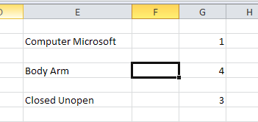
3. Highlight the column with the double words.
4. Hit data tab (at the top menu bar), then text to columns.
5. 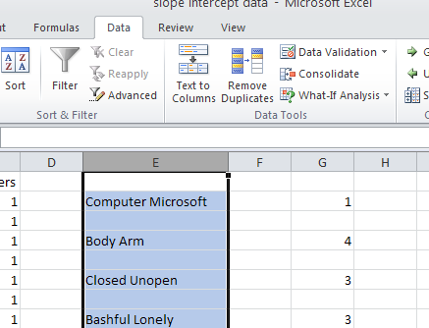
6. It will come up as delimited – hit next.
7. 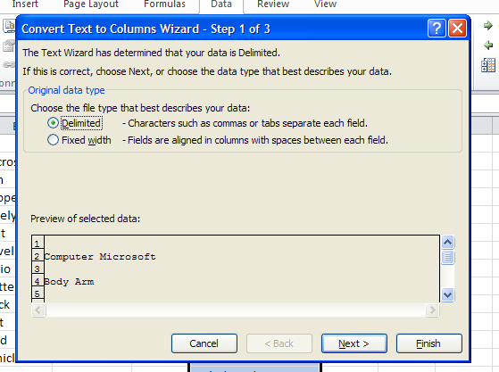
8. On the next screen hit space and then finish.
9. 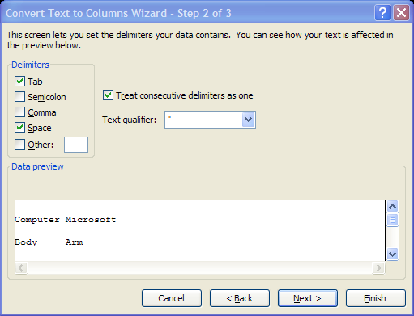
10. Now you should have this:
11. 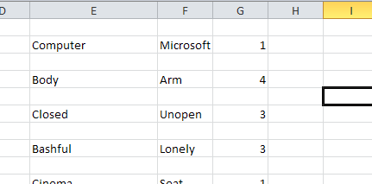

Highlight the first 3 columns and sort by word 1, then word 2.

Highlight these new 3 columns and do the same thing. Now they should line up.

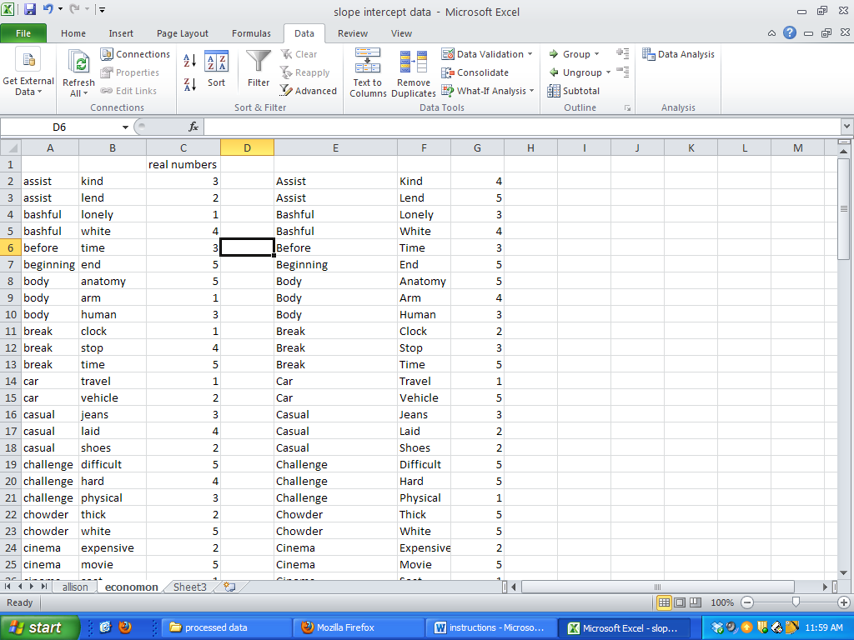

You should end up with 42 different sheets for people.